Task 1: Connect Laptop and Phone to the Same Wi-Fi and Test Using Ping

Procedure
- Turn on the Wi-Fi on both the laptop and the friend's mobile phone.
- Connect both devices to the same Wi-Fi network.
- On the mobile phone: open Settings → Wi-Fi → Connected Network and note down the IP Address.
- On the laptop, press Windows + R → Type cmd → press Enter to open Command Prompt.
- In the Command Prompt, type the following command: ping [phone’s Ip address]
- Press Enter.
- Wait for the ping process to complete and observe the results.
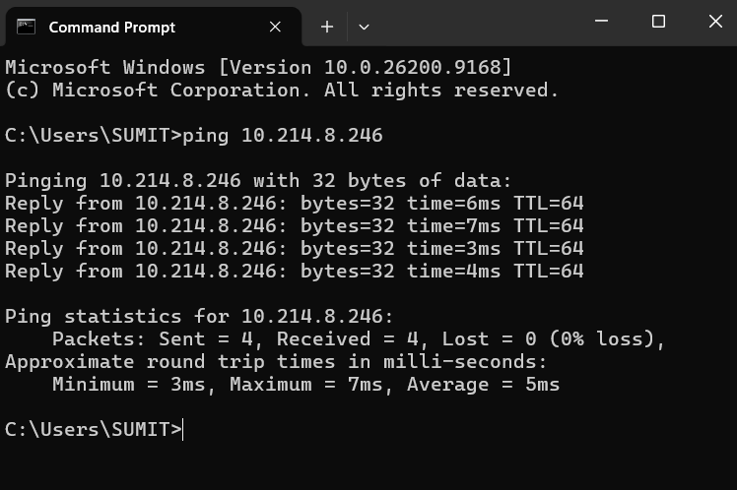

Task 2: Run Traceroute to YouTube

Procedure:
- Open command prompt
- TYPE: tracert www.youtube.com
- Press entre
- Wait until command is complete
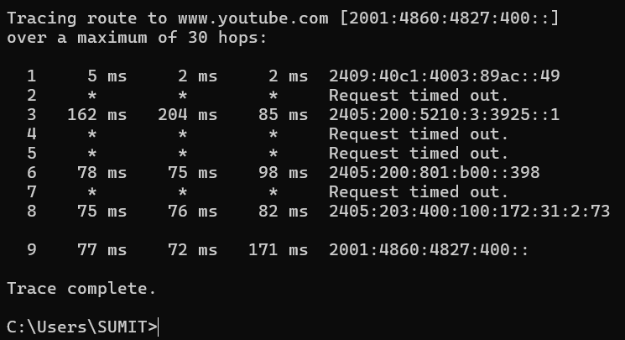
Total Hops to Destination: 9 hops

Task 3: Disconnected Device Test Ping & Error Analysis

Procedure:
- Connected the laptop and mobile phone to the same Wi-Fi network.
- Verified that both devices could communicate using the ping command.
- Turned OFF the Wi-Fi on the mobile phone.
- Opened Command Prompt on the laptop.
- Executed the following command: ping 10.214.8.137 (EXAMPLE)
- Observe the error occurs on the screen
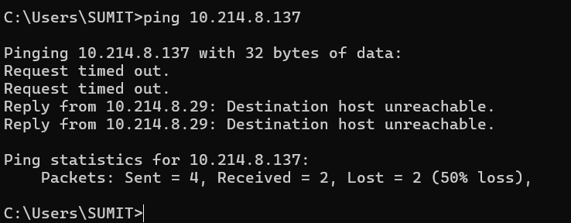
It typically see one of these results:
- "Request timed out" — the laptop sent the ping but got no reply, since the device is no longer on the network.
- "Destination host unreachable" — the network couldn't even find a path to that device.

Task 4 — List connected devices using arp -a

Procedure:
- Connect the laptop to the home Wi-Fi network.
- Press Windows + R: Type cmd and press Enter to open Command Prompt.
- Type the following command: arp -a and Press Enter.
- Observe the list of IP addresses and Physical (MAC) addresses displayed.
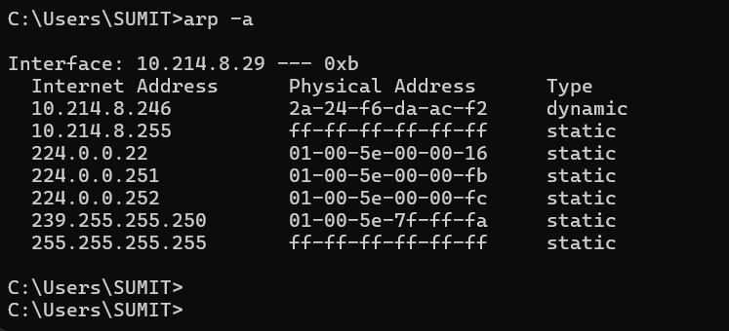

Task 5: Network Setup & Diagnostic Testing Report

Network Setup and Testing Report
Objective:
The goal of this exercise was to connect multiple devices to the same Wi-Fi network and test connectivity between them using ping and traceroute, in order to understand how devices communicate on a local network and reach the wider internet.
Setup:
I connected my laptop and another device to the same home Wi-Fi network. I found each device's IP address using ipconfig on the laptop and the Wi-Fi settings menu on the phone. The laptop's IP was [10.214.8.29], and the phone's IP was [10.214.8.137], both within the same subnet, confirming they were on the same local network.
Ping Test (local device to device):
I ran ping 10.214.8.137 from Command Prompt on the laptop. The result showed 4 successful replies with response times around 5 ms, confirming that the two devices could successfully communicate with each other on the local network.
Traceroute Test (laptop to youtube.com):
I ran tracert www.youtube.com and observed the request pass through 9 hops before reaching YouTube's servers, taking a total of roughly 80 ms. Each hop represents a router along the path from my network to YouTube's infrastructure.
Disconnected Device Test:
After disconnecting the phone from Wi-Fi, I ran the same ping command again. This time, I received [“Request timed out” / “Destination host unreachable”] for all 4 attempts, confirming the device was no longer reachable on the network.
Connected Devices List:
Using arp -a on the laptop, I identified the following devices on the network: the router at [IP], my laptop at [IP], and [other devices] at their respective IPs, matched by comparing each device's own reported IP address.
Conclusion:
This exercise showed how ping confirms basic reachability between devices, traceroute reveals the path data takes to reach an external server, and tools like arp -a help map out which devices are active on a local network.
